**RBAC Blockchain Demo**

**Guide**

**Sandia National Laboratories**

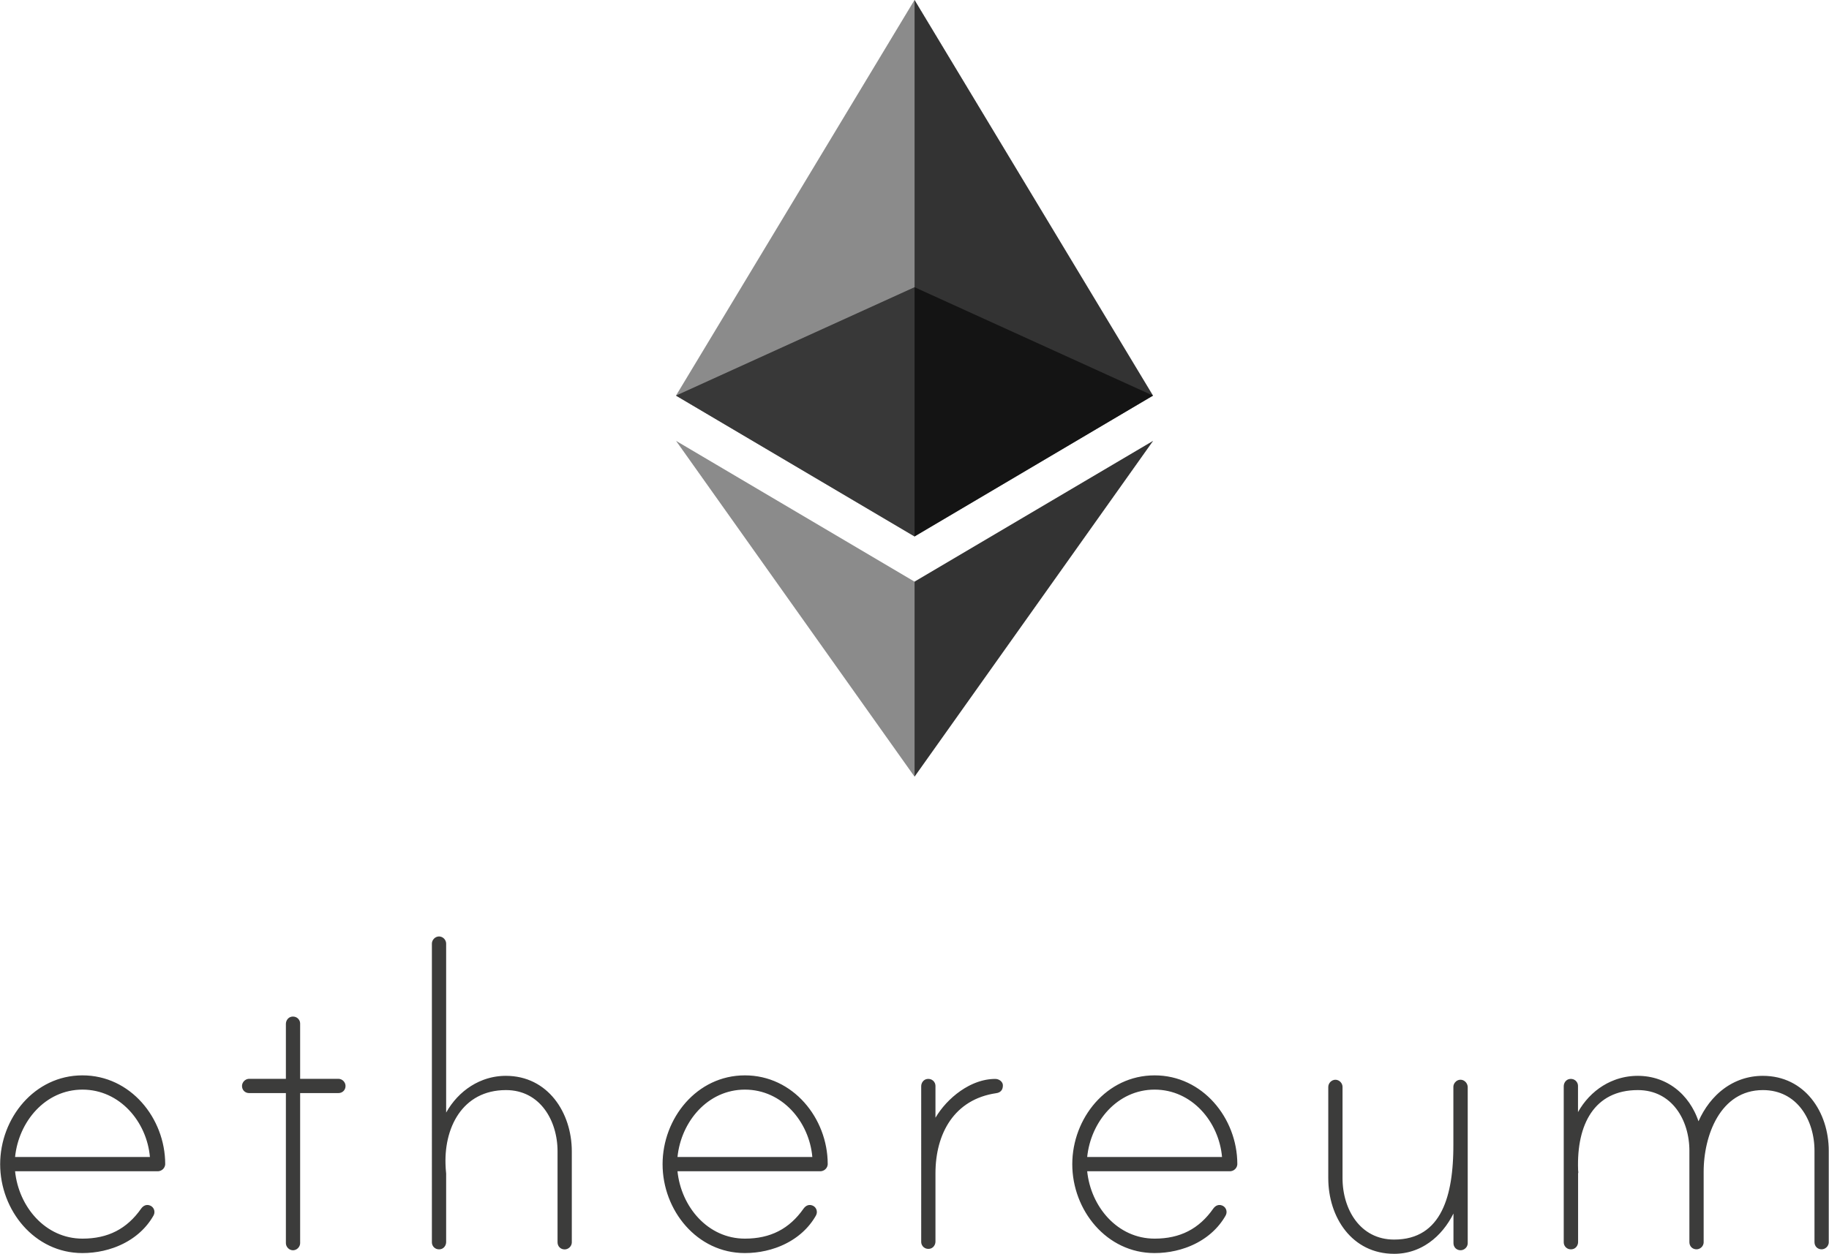

Please follow this guide in order to navigate through the RBAC OpenLDAP demo that we have created.

1. Go to <http://10.12.11.104/:8081> , where you can find the Login Page. You can login with one of the following identities:

* *User*: Simple user that can see basic information about the Blockchain and is able to perform a query regarding her permissions.
* *Admin*: The administrator of the whole RBAC system. She can perform CRUD actions to all the DER entities. ***We suggest to login as an Admin in order to see the full potential of our RBAC Blockchain architecture.***
* *Utilities Admin:* The administrator of the Utilities in the DER ecosystem. She can perform CRUD actions only to the DER Utilities entities.
* *Service Providers Admin:* The administrator of the Service Providers in the DER ecosystem. She can perform CRUD actions only to the DER Service Providers entities.
* *DER Owners Admin:* The administrator of the DER Owners in the DER ecosystem. She can perform CRUD actions only to the DER Owners entities.

***Note****: In the followings we assume that you have logged in the system as* **Admin.**

1. In the Admin page you can click initially the “Your Profile” button.

When you click this button, you can see some information regarding the Ethereum blockchain such as the Admin’s Ethereum address and balance (in ethers). Additionally, you can see the public address of the RBAC Smart Contract that is deployed in the blockchain.

1. Afterwards, you can click the ‘Utilities’ in the navigation bar on top of the page and you will be transferred in the Utilities Section of the Admin page. There select the ‘Utility x’ box (where x can be 1, 2, 3, 4 or 5).

1. Then you will be transferred to the Utility x page, where you can see all the DER entities (DERs and users) that are associated with this Utility. You can see there the entities’ username, Ethereum Address, RBAC role and the respective actions that you can do.

**[NOTE: In order to see the changes that you make with all the following queries in the Utilities or Service Providers tabs, you may have to refresh the respective pages in your browser.]**

1. Let’s scroll down in order to find a specific user that is associated with Utility x.
   1. *Update Operation:* We can click on the username/role of the entity that we chose to update and change it based on our preference. [*Eth Address cannot be changed!]*

We changed the last name of the entity to Test User. Then click the ‘Update Entity’ button. You should see the following pop-up window:

Now, by clicking the ‘Go to Top’ button on the right you can go to the top of the page and search for the user that you changed his username in the search bar. We should note that in this search bar you can search by username, Ethereum Address or RBAC role.

Click the ‘Revoke Role’ button, in order to revoke the entity’s RBAC role. You can see in the following screenshot that the role is successfully revoked from the system and it is not shown in the ‘RBAC Role’ column.

Click the ‘Show Permissions’ button, in order to show the permissions of an DER entity. We should note the following things:

* For space convenience, we only show the DERCapacity model’s permissions.
* In case you click this button for a DER, then you will not see any permissions. The DERs are the objects of the RBAC model.

1. If you click the ‘MY DASHBOARD’ button in the navigation bar, you will return in the main page of the Admin user. There you can perform all the aforementioned operations for all the Utilities, Service Providers, DER Owners and Security Entities by following the corresponding actions that were presented above.
2. Please select the ‘Query’ section in the Navigation Bar, in order to go to the respective page.

Here you can perform the following actions/queries:

* Search User [Provide username and/or Ethereum Address – not DER]

* Add User [Provide first and last name, role, associated DER entity and a DER device in case the new user has a role ‘DER Owner’ – **Takes some time to be executed because it adds all the models, permissions of the role**]

* Graphical user interface, application, Teams

  Description automatically generatedSearch DER [Provide the DER name and/or the Ethereum Address]
* Add DER Device [Provide a DER name and the organizations that you want to be associated with – you can choose many organizations.]

* Verify User-To-Role Assignment [Provide username and/or address, and the RBAC role that you want to check]

* Delete User [Provide username and/or Ethereum Address – not DER, **Takes some time to be executed because it deletes all the models, permissions, and role**]

* Check Permissions [Provide the username and/or the Ethereum address, the DER device that you want to perform an operation on, the DER model such as DERCapacity or DERMeasureAC for instance, and the corresponding register]

* Graphical user interface, website

  Description automatically generatedSearch Block [Put an integer number – You can check some basic information about the Blockchain’s blocks]
* Search Transaction [Put the hash of a transaction]

* A picture containing text

  Description automatically generatedDownload Log File [By clicking the button, you will find in the Downloads Folder of your pc the respective log file of the Ethereum Blockchain.]

1. By clicking the ‘SIGN OUT’ button in the navigation bar you can sign out from the Admin page and select again how you want to login in the application. As we mentioned in Step 1, all the Admin users can handle the corresponding entities. e.g., the Utilities Admin can see and edit all the Utilities entities.
2. Let’s now click on the ‘User’ button, in order to login as a User.

1. Let’s now click again the ‘Your Profile’ button, where we can see again some basic information regarding the Blockchain such as the user’s Ethereum balance in ethers and the public address of the Smart Contract. Since the user is not an Administrator, she cannot see/edit the Utilities, Service Providers, DER Owners and the Security Entities. She can only perform a permission query in order to get an RBAC Access Token (Check the next step).

1. Let’s select the ‘Permission Query’ tab in the user’s navigation bar in order to perform a query. You should provide the username, DER name, DER model, register and also the operation that you want to perform (R, W, RW).

Based on the permissions, the access toke will be (or will not be) granted.

1. You can afterwards click the back button in your browser and go to the User’s page. At the bottom of the page, you can find the ‘Contact Us’ section, where you can send to us your feedback regarding the demo! Thank you!